What is Docker Desktop?

Simplified Containerization: Docker Desktop is a software application that makes it incredibly easy to build, run, and manage software containers on your Windows or Mac computer.

Key Components:

* Docker Engine: The core technology that allows you to create and manage containers.
* Docker CLI: The command-line interface you use to interact with Docker.
* Docker Desktop UI: A user-friendly dashboard to manage images, containers, volumes, and more without having to memorize commands.

What is Docker Desktop used for?

1. Development Environments:

* Consistency: Create identical development environments across different machines, avoiding "it works on my machine" issues.
* Ease: Package complex setups into a single container image (web server, database, tools).

1. Microservices:

* Modularity: Build and deploy individual components of your application as isolated containers, making updates and scaling easier.

1. Testing:

* Clean Environments: Run tests in fresh, repeatable containers, ensuring reliable results.

1. Shipping Software:

* "Build Once, Run Anywhere": Package your application and its dependencies into an image that can be easily deployed on any machine running Docker.

Key Points

* Docker Desktop streamlines the sometimes complex process of working with containers.
* It benefits developers, system administrators, and anyone who needs to package and run software consistently across different environments.

Downloading Docker

Docker Desktop:

* Visit the official website: https://www.docker.com/products/docker-desktop
* Download the installer for your operating system.

Docker Engine (Linux)

* Instructions are distro-specific; find them on Docker's docs: https://docs.docker.com/engine/install/
* Usually involves updating package lists and using your distro's package manager (e.g., apt-get for Ubuntu).

Installation:

Docker Desktop:

* Run the downloaded installer and follow the on-screen prompts.

Post-Installation

* Verify: Open a terminal/command prompt and run docker version. This should confirm successful installation.
* Permissions (Linux): You might need to add your user to the docker group to run Docker commands without sudo. Refer to post-install docs here: <https://docs.docker.com/engine/install/linux-postinstall/>

Let's Get Started!

* Docker Basics: Familiarize yourself with fundamental Docker commands like docker run, docker build, and docker pull. There are numerous tutorials online.
* First Container: Try running a simple container like docker run hello-world.

Project folder: You have your project folder with the following files:

* Dockerfile
* app.py

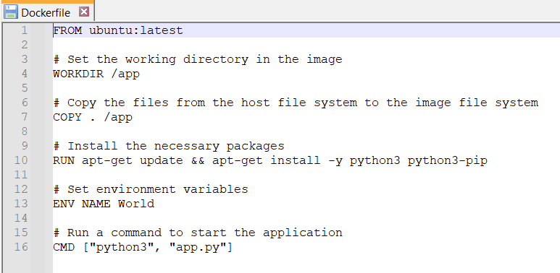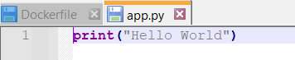

1. Building the Docker Image

* Navigate to the Project Directory: In your command prompt/terminal, use the cd command to navigate to the folder containing your Dockerfile.
* The dir command is a fundamental command-line utility used in Windows operating systems (primarily in the Command Prompt and PowerShell environments) to list the contents of a directory.

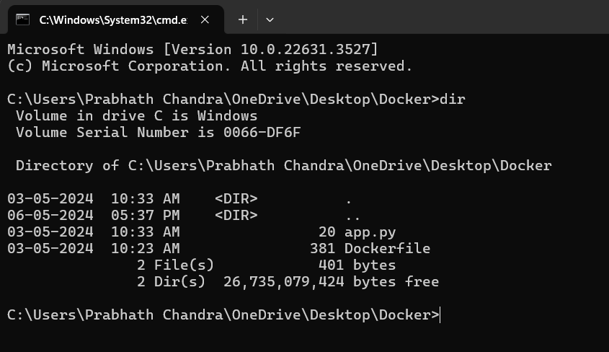

* The type command displays the contents of a text file directly in your command prompt window. This is useful for quickly viewing the contents of smaller files.

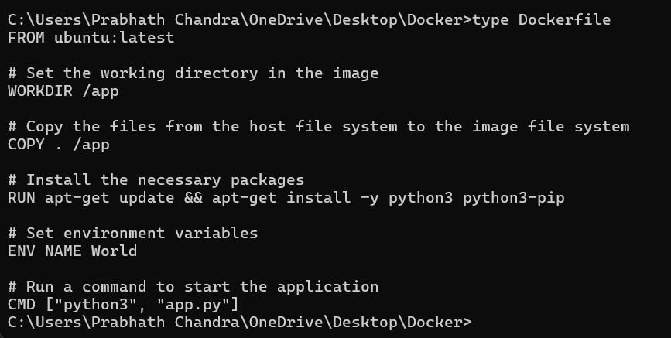

The docker build command plays a central role in creating Docker images, which are the core building blocks for running software in containers.

1. Reads the Dockerfile: The build process starts with a file aptly named Dockerfile. This file contains a set of instructions that define how your image should be constructed.

2. Follow the Instructions: The docker build command meticulously executes each instruction in your Dockerfile in sequential order.

3. Creates Layers: Each instruction in your Dockerfile creates a new layer in the image. Layers are like snapshots of the changes made at each step. This layering system is key to Docker's efficiency.

**4.** Assembles the Final Image: Once all instructions are processed, the docker build command packages the resulting layers and metadata into a complete Docker image. This image is a portable blueprint for creating running containers.

Build Command: Execute the following command to build the image:

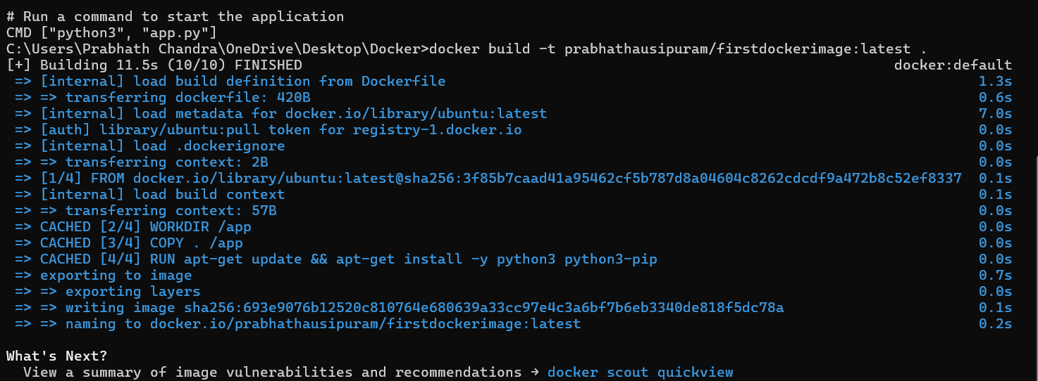

* -t tags your image with the name and repository.
* . specifies the build context (the current directory).

Example:

If your Dockerfile is simple:

FROM python:3.9

COPY app.py /app

CMD ["python3", "app.py"]

The docker build command will:

* Start with a base image containing Python 3.9.
* Copy your app.py file into the image.
* Set the default command to run your Python script.

Build Context: The docker build command usually uses the current directory as the build context. Files you COPY into the image should be in this context.

Tagging: Use the -t flag to name and tag your image (e.g., docker build -t my-app-image .)

2. The docker images command is your gateway to managing Docker images on your system.

Shows Locally Available Images: The most basic use of Docker images lists the Docker images that have been built or pulled onto your machine. This includes:

* Image Name and Tag: Identifies different versions of an image.
* Image ID: A unique identifier.
* Creation Time: When the image was built or downloaded.
* Size: The disk space the image occupies.

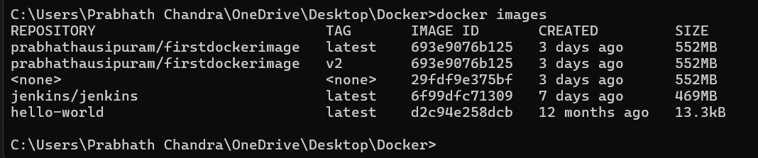

3. Running the Container

Run Command: Run your image as a container: The docker run command is the fundamental way you execute a Docker image to create a running instance, called a container.

* -it:
* -i: Keeps STDIN (standard input) open, allowing you to interact with the running process inside the container.
* -t: Allocates a pseudo-TTY (a text-based terminal), giving you a command-line like interface within the container.
* prabhathausipuram/firstdockerimage:latest:
* Specifies the Docker image to use. Here, it's an image named "firstdockerimage" from the repository "prabhathausipuram", using the "latest" tag.
* .: (The Single Dot)
* This likely isn't doing anything useful in this specific context. It's common to see commands like docker run -it my-image some-command to override the image's default command, but that doesn't seem to be the intention here.

Here's the step-by-step process:

* Base Image: Docker begins with a base image of ubuntu:latest, providing a basic Ubuntu Linux environment.
* Working Directory: The WORKDIR /app instruction sets the working directory inside the container to /app. Subsequent commands will operate within this directory.
* Copying Files: COPY . /app copies all files from your project directory on your host machine into the /app directory within the image.
* Installing Packages: RUN apt-get update && apt-get install -y python3 python3-pip updates the package list in the container and installs Python 3 along with its package manager, pip.
* Environment Variable: ENV NAME World sets an environment variable named "NAME" with the value "World" inside the container, but this isn't directly used by your current app.py.
* Default Command: CMD ["python3", "app.py"] specifies that when a container is started from this image, it should execute the command python3 app.py.

Interactive Terminal: The -it flags in your docker run command allocate an interactive text-based terminal (TTY) and attach your standard input to the container.

Output: Since your app.py simply has print("Hello World"), here's what you'll see:

* The container will start up.
* Python will execute your app.py file.
* "Hello World" will be printed directly to your terminal.
* The app.py script finishes, and the container will then immediately exit.



4. Pushing the Image to a Docker Registry

Assumption: You have an account on a registry like Docker Hub. If not, you'll need to create one.

Login: Log in to your Docker registry:

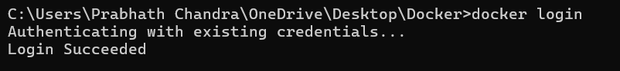

5. Push Command: Push your image to the registry:

Note: As I have already pushed it earlier, it shows that the layer already exists.

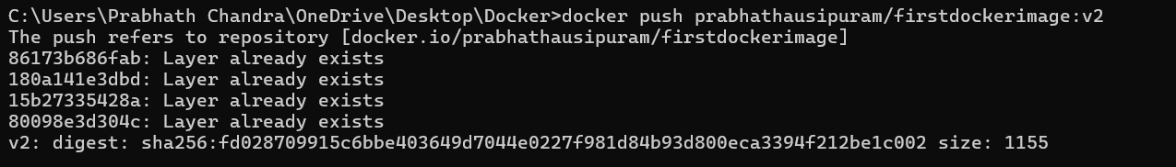

6. Pulling the Image (on a Different Machine)

Login: Ensure you're logged into the Docker registry.

Pull Command: Pull the image:



Additional Notes:

Container Management:

* List running containers: docker ps
* Stop a container: docker stop <container_id>

Image Management:

* List images: docker images
* Remove an image: docker rmi <image_id>

Consider using version tags when pushing images (e.g., prabhathausipuram/firstdockerimage:v1.0)